Operating System

|  |  |
| --- | --- |
| **Student name** | **ID** |
| **Mahmoud Essam Fathy** | **20221460231** |
| **Abdelrahman Ashraf Ragab** | **20221374041** |
| **Abdullah Hussein Ibrahim** | **20221427861** |
| **Zyad Ashraf Hafez** | **20221374025** |
| **Marwan Ali Abd-Elsatar** | **20221460240** |

What’s Memory Management?

**Memory management in your FreeBSD**

Supervised by

Dr. Yasser Fouad

We can consider memory as the core of the Personal Computer’s life, as the memory management system holds a main role in every operating system, tasked with the efficient management of memory resources, organized in a hierarchical manner. This hierarchy usually encompasses multiple memory levels, with memory access times being inversely related to their proximity to the CPU.

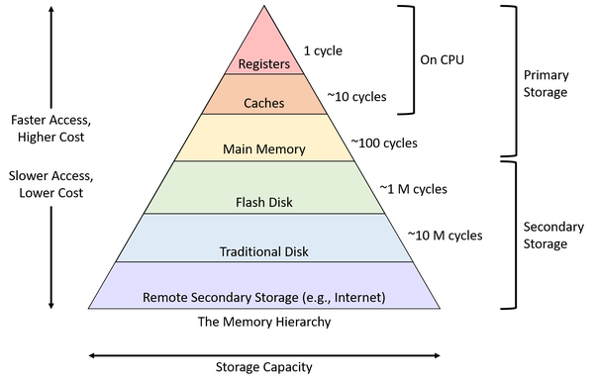The main memory is like the top level, and just below it is secondary storage, which is usually on disk drives. Some work setups use a three-level system with file servers or network storage connected to workstations using a local network.

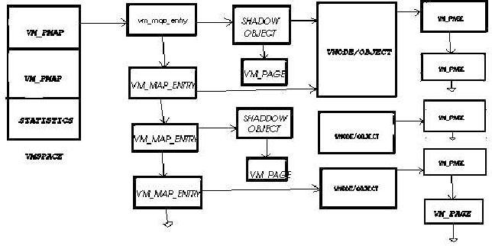

____________________________________________________________________________________________________________________

What About FreeBSD, how does it work?

* The virtual machine (VM) used by FreeBSD uses memory as pages, which are typically 4KB in size on most systems.
  + Which one Page means refers to the fundamental unit of memory management within the operating system.
  + page is a fixed-size block of memory used for various purposes, including the allocation of physical memory and the management of virtual memory
* FreeBSD manages pageable memory using three queues. Top(1) displays the sizes of the three queues Laundry, Inactive, and Active.

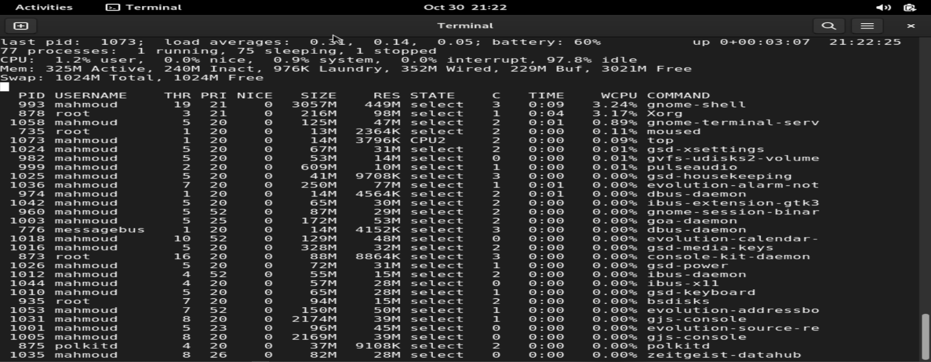

(This image show processes on the system and all needed consuming resources, even in CPU and Ram)

Pageable memory is like a big notebook for your computer. When your computer needs to use something, it wrote in the notebook but doesn't have enough space, it's like moving that info to another notebook (the swap device) and erasing it from the big one•

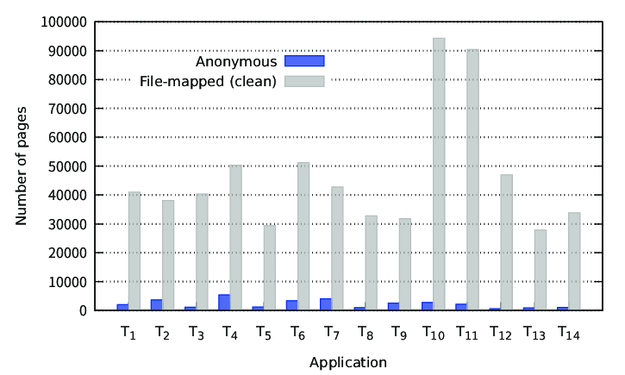if your computer wants to use that info again, it checks the swap notebook, finds what it needs, and puts it back in the big notebook. If there's not enough space in the big notebook, it might erase some less important stuff to make room. The stuff in the swap notebook is like secret notes your computer keeps, and it's called "anonymous memory."

Examples of anonymous memory include:

1. Memory allocated by malloc() in applications.
2. Contents of a swap-type MD device.
3. Data in tmpfs filesystems.
4. Shared memory in SysV or POSIX segments.

Think of file data as your computer's saved files and information. The computer has a special memory space just for these files. Different systems call it by different names, like "buffer cache" in UFS, msdosfs, and NFS, and "ARC" in ZFS.

When we need space for new stuff, the old data in the memory space waits in a line (like a queue) called the "inactive queue." But in ZFS, it's like the old data goes away right away without waiting in line.

Pages in page queues can be either "clean" or "dirty." Dirty pages need to be saved before they can be used again, at which point they become clean.

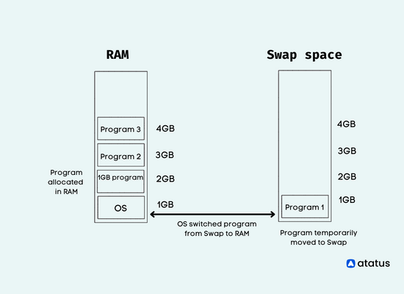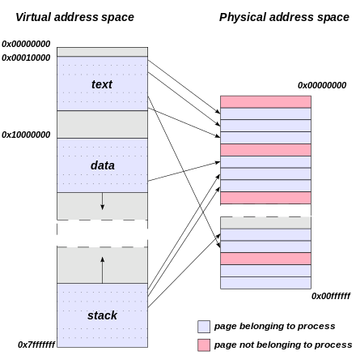Dirty anonymous pages are cleaned by saving their contents to the swap device. Dirty file pages are cleaned by saving their contents to the filesystem's main storage. Once a page is clean, it's ready to be freed up and used again.

____________________________________________________________________________________________________________________

What about memory classes?

FreeBSD memory Classes organized into different classes:

**Active:**

* Holds recently used pages by programs.
* Contains both clean and dirty pages (clean means unaltered, dirty means changed).
* Pages are regularly checked by the page daemon (a background process) to see if they've been used recently.
* If a page hasn't been used in a while, it's moved to the inactive queue.
* It uses a pseudo-Least Recently Used (LRU) method to manage pages.

**Inactive:**

* Holds pages that have been moved out of the active queue.
* Also contains pages kicked out of the buffer cache (where files are stored temporarily).
* Pages are scanned when there's a memory shortage.

PLRU is like a smarter version of LRU. It doesn't keep track of exact ages; it guesses which items to replace based on rough estimates of their age.

* Referenced pages go back to the active queue.
* Dirty pages are moved to a queue for cleaning.
* Unused, clean pages can be freed up right away.
* Uses a second-chance LRU method to manage pages.

a combination of using a queue, similar to FIFO

**Laundry:**

* A queue for managing dirty (changed) inactive pages that need cleaning before they can be used again.
* Managed by a separate thread called the laundry thread.
* Cleaning frequency depends on various factors.
* Referenced pages go back to the active queue.
* Dirty pages are cleaned and put back in the inactive queue.
* Helps maintain a balance between the inactive and laundry queues.

**Free:**

* Memory that's available for use by the whole system.

**Wired:**

* Non-pageable memory, meaning it can't be freed automatically.
* Userland memory can be "wired" by certain commands (like mlock).
* Kernel memory and the contents of the ARC and buffer cache are also wired.
* Some memory, like the kernel itself, is always wired and never released.

